Study Material Distribution to I Year/I Semester Students

- Study material relating to the subject “Information Technology” was distributed to students of I Year/I Semester of the academic year 2021-22.
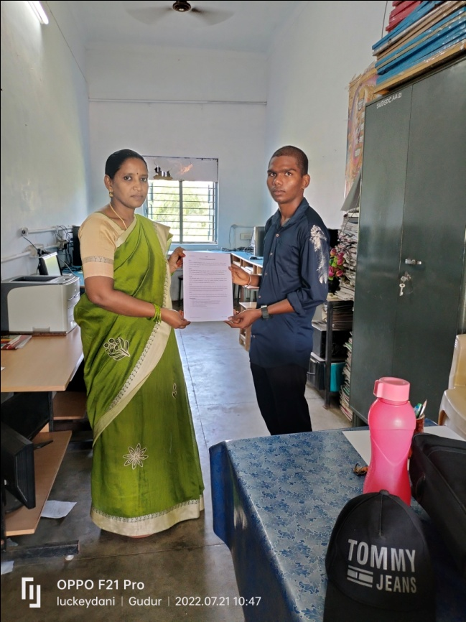

Signature of the Lecturer Principal

STUDY MATERIAL DISTRIBUTION TO II YEAR/IV SEMESTER STUDENTS
Study material relating to the subject “Database Management System (DBMS)” was distributed to students of II Year/IV Semester of the academic year 2021-22.

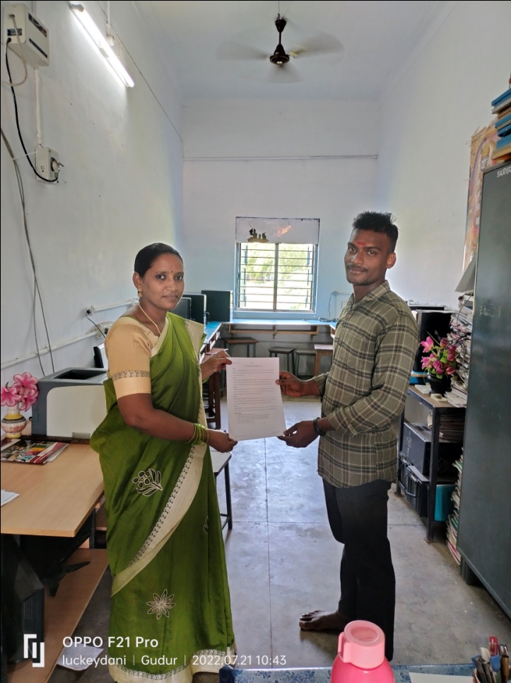

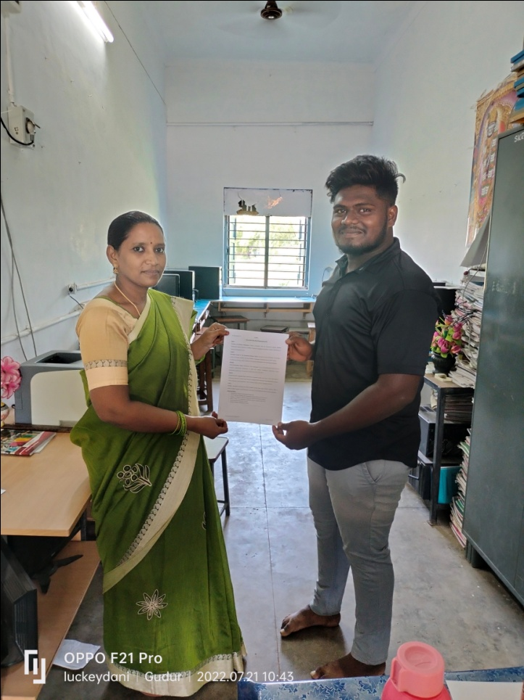

Signature of the Lecturer Principal

STUDENT SEMINAR PRESENTATION USING ICT TOOLS
The students are encouraged to present seminars by using ICT Tools. Following are the list of mobile apps used by the students to present their seminars.
- Google Slides - To prepare presentations
- Screen Recorder - To record seminars
- Google drive - To share the seminar link
- Video recorder - To record the seminar

Links of recorded videos:

- https://docs.google.com/presentation/d/1CCuBBTO77TI3r9XHBhx2sPagp9WaV76X/edit?usp=drivesdk&ouid=109525951016132746970&rtpof=true&sd=true
- https://drive.google.com/file/d/1KKWWbdbTzcQDBRDkucr6VumSb32kKviK/view?usp=drivesdk
- https://drive.google.com/file/d/1j8QIIfvZvuKL833pp2_URIhP4suhEK1m/view?usp=drivesdk
- https://drive.google.com/file/d/11EoeGfL1W37sZq_hy7lyJgAVb8oMdUCY/view?usp=sharing

Usage of WhatsApp Groups to Share Materials and Academic Information

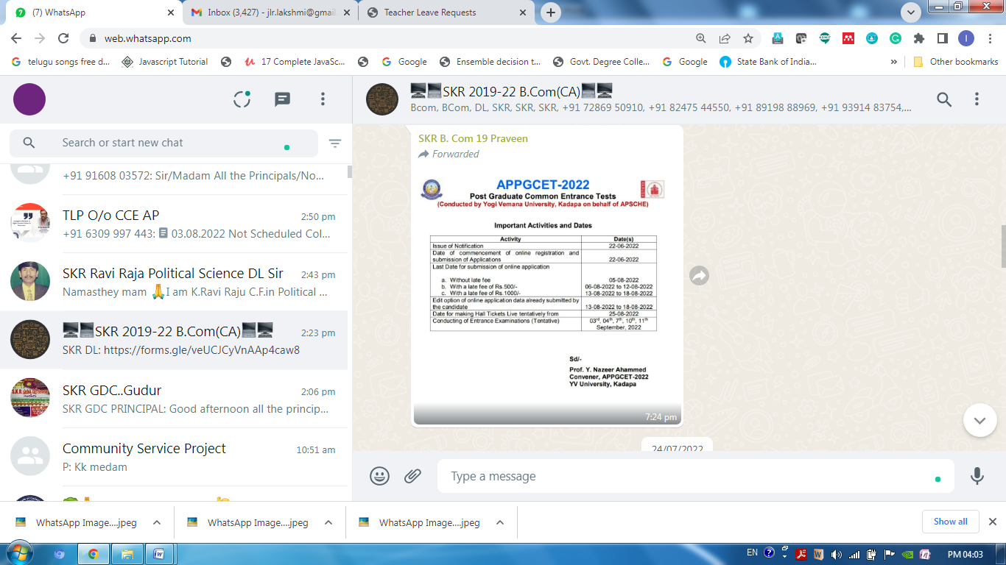

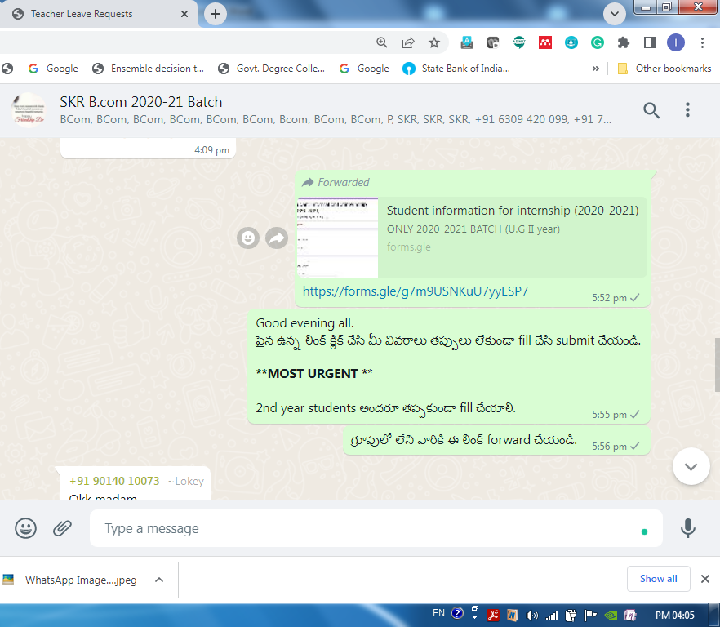

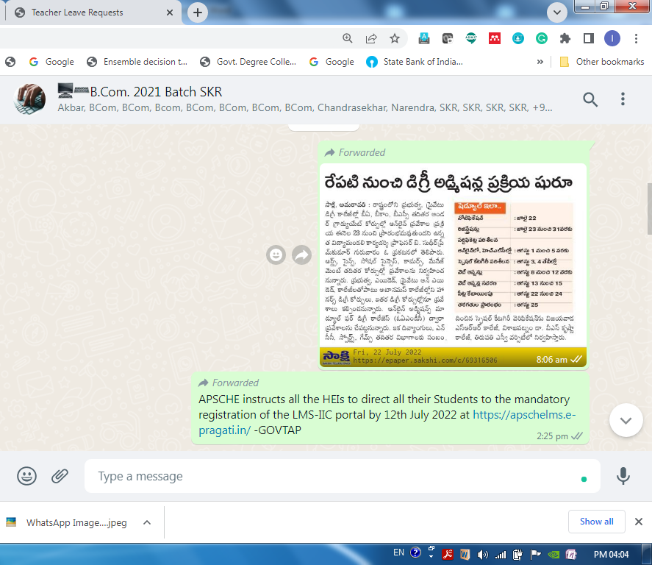

Using Mobile Compilers and Editors to Practice Lab Exercises at Any Time and Any Where

Example Apps:
- SQLCode – To practice SQL Commands
- Coding With C - To practice C programs
- HTML Editor - To practice HTML programs
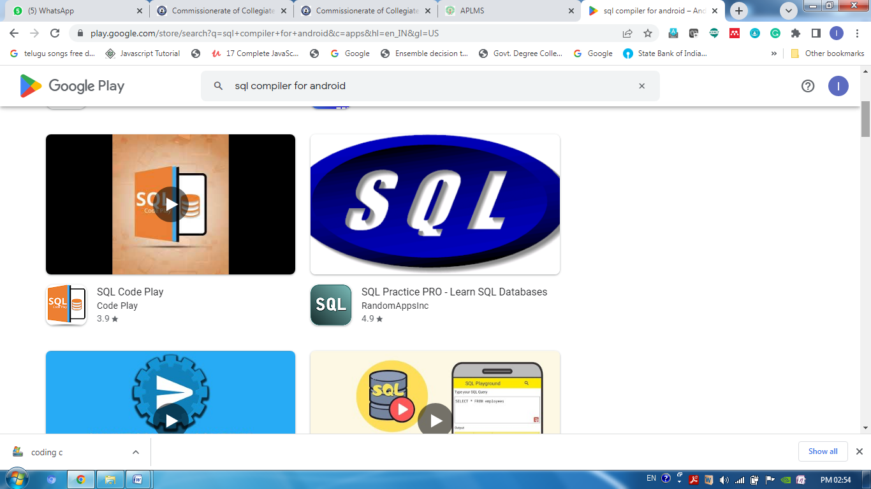

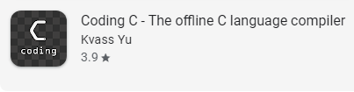
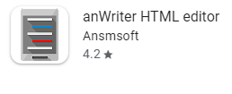

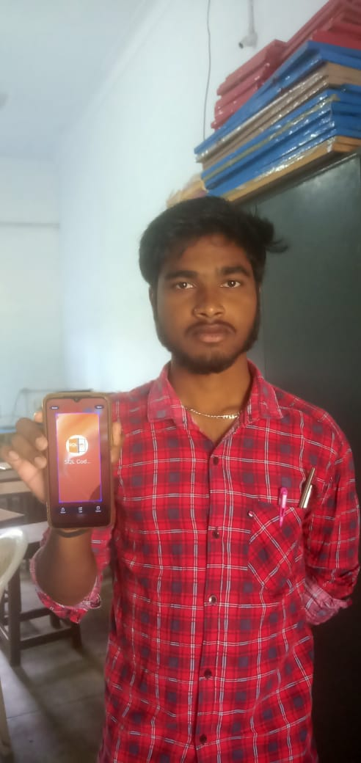 | 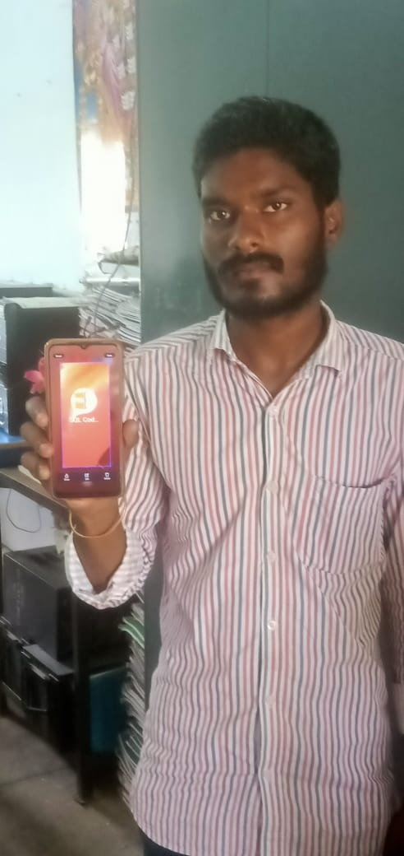

Working with Shortcuts while using MS-Word and other apps

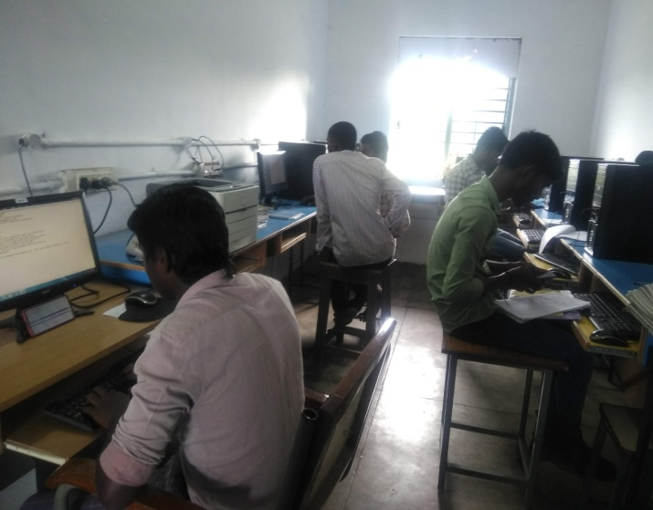

Usage of Keyboard and Practicing Typing

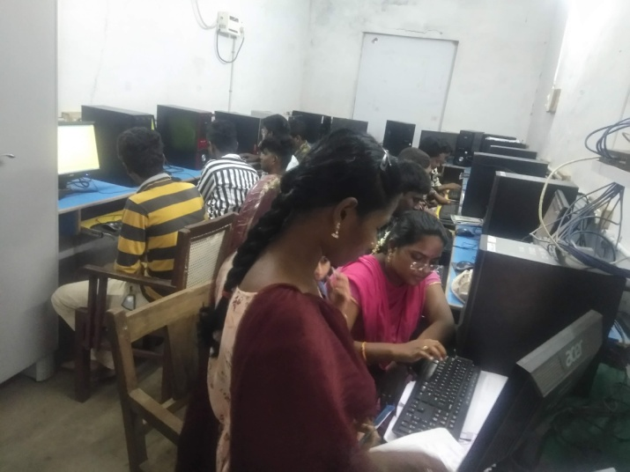

Identification of Peripheral devices and its Assembling

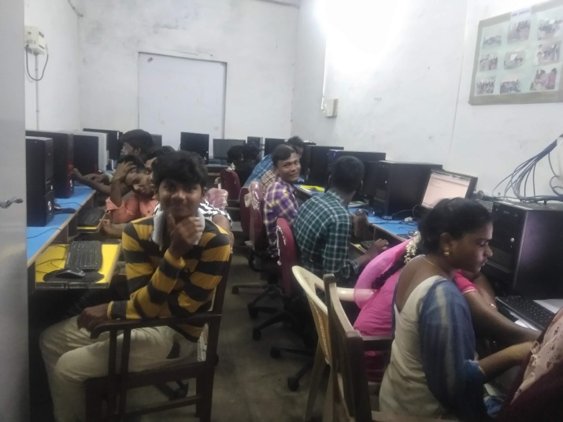

Prize Distribution to Quiz Winners and Participants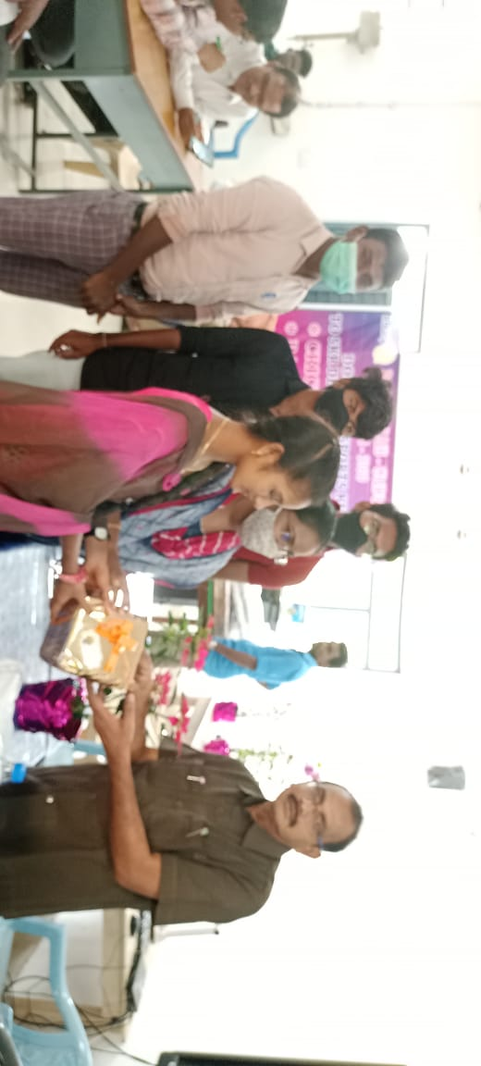

Prize Distribution for Good Academic Performance

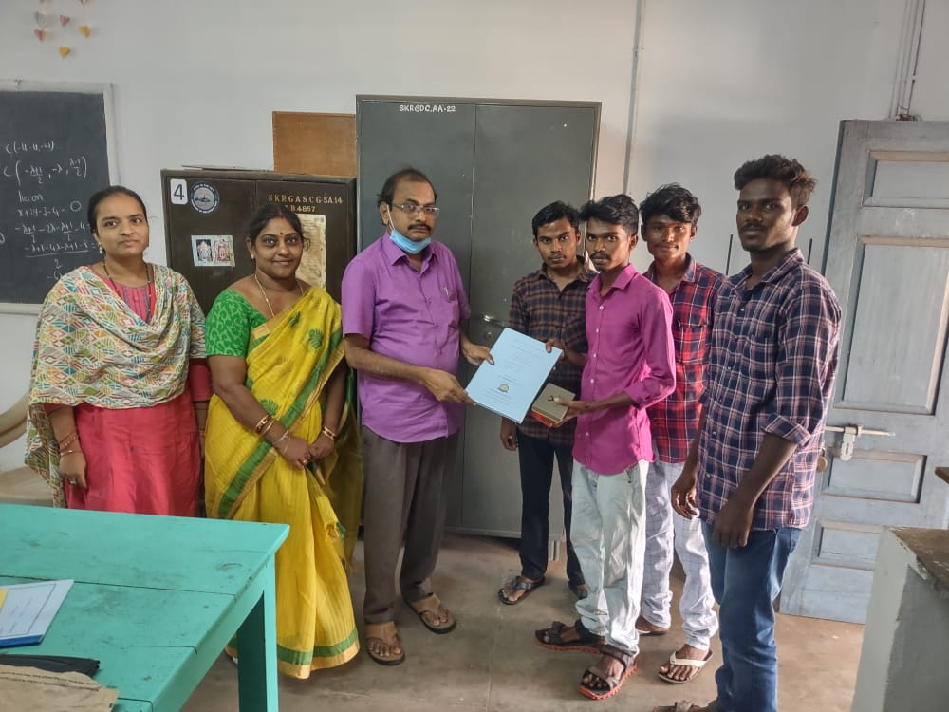 | 